This code helps to find the pixel displacement of features in a series of consecutive frames.
Before getting started, please make sure that all MATLAB files are in the same folder.
To divide a movie into frames, you can use “MP4toTif.m”

1. Step: Filename list generation with filelist_generator.m

Just type “filelist_generator;” and press ‘ENTER’ at the command line of MATLAB. The following window should appear:

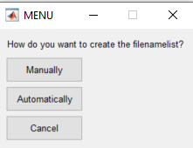

If you select automatically, the following menu will ask you for the first image you would like to process:
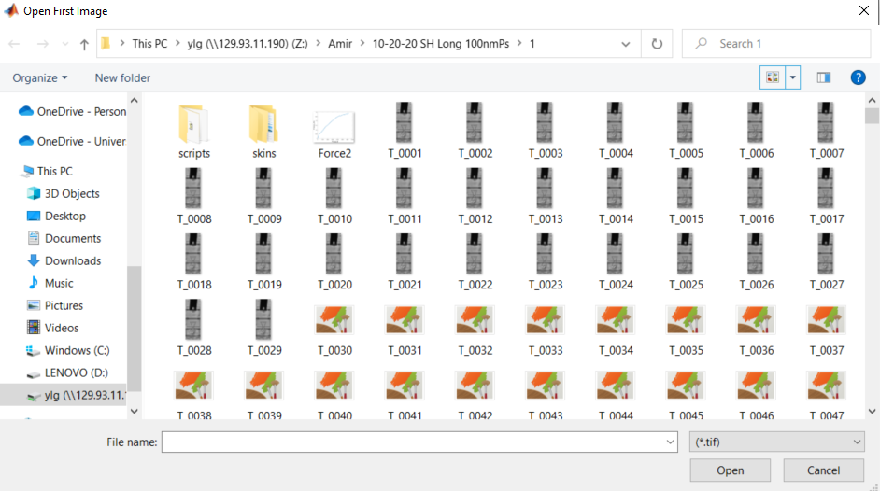

Here you can select e.g. T_0001.tif. You will be asked to save the file, please do not change the name of the filename list as automate_image and other tools will need it. You should also save the file in the folder where your images are. After that, you will be asked if you want to read out the time from the images:



If you answer yes MATLAB can read the acquisition time from your images.

2. Grid generation with grid_generator.m for correlation

It has to be noted that the user can always generate his marker positions. Therefore the marker position in pixel has to be saved as a text-based format where the x-position is saved as ‘grid_x.dat’ and the y-position saved as ‘grid_y.dat’.
To start just type “grid_generator;” and press ‘ENTER’ at the command line of MATLAB. The following window should appear:

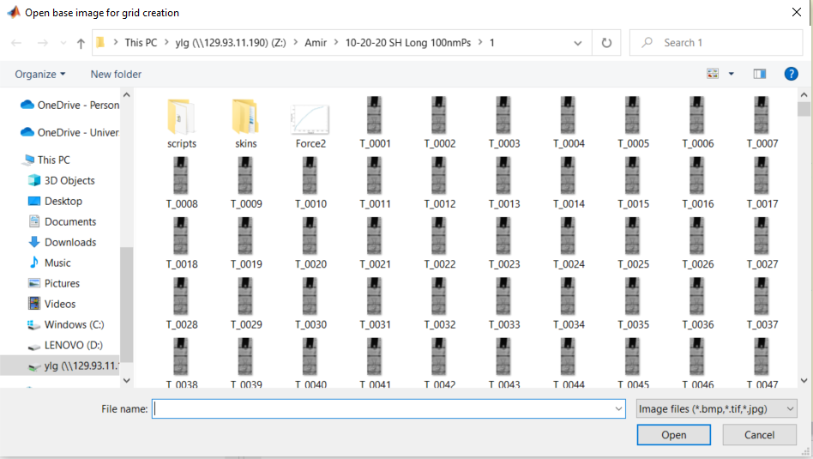

In this dialog, the first (base) image can be selected in which the grid can be created. After selecting this base image, the image will be opened and a new dialog pops up to ask you if you would like to load an existing grid. If you want to create a new one just hit No and go ahead.

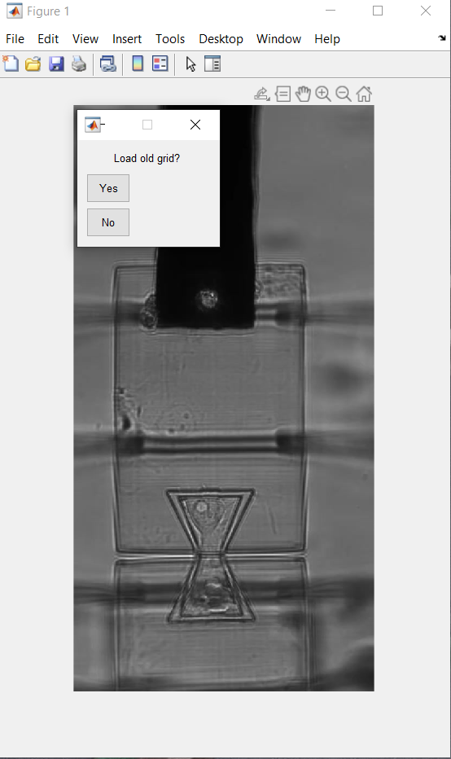

You will get a new choice where you can select a shape for your grid.

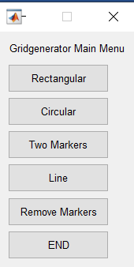

The different types are a rectangular or circular grid, two markers, or a line of markers. If you choose a rectangular grid type, the pointer will change from an arrow to a horizontal and a vertical line which will help you find the right position. The idea is to click on the two diagonal positions which will define the outer dimensions of a box containing the grid.

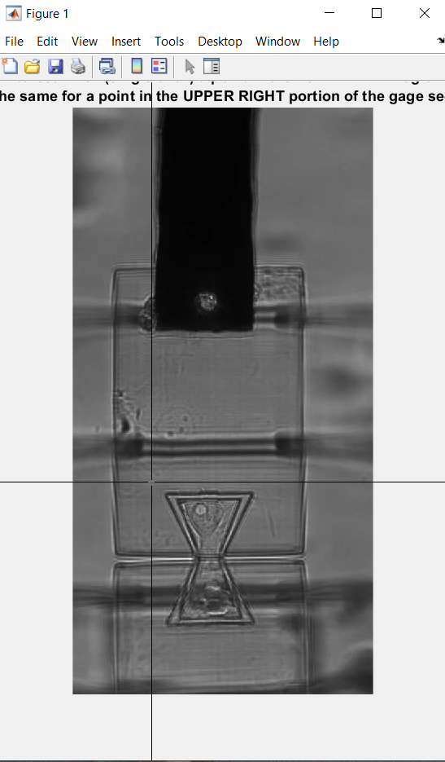

The selected box will be shown in the image and a dialog will pop up to ask you for the input of a raster point distance in the x and y-direction.

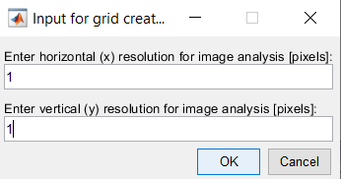

The code will now generate the chosen grid and will plot it on top of the sample image.

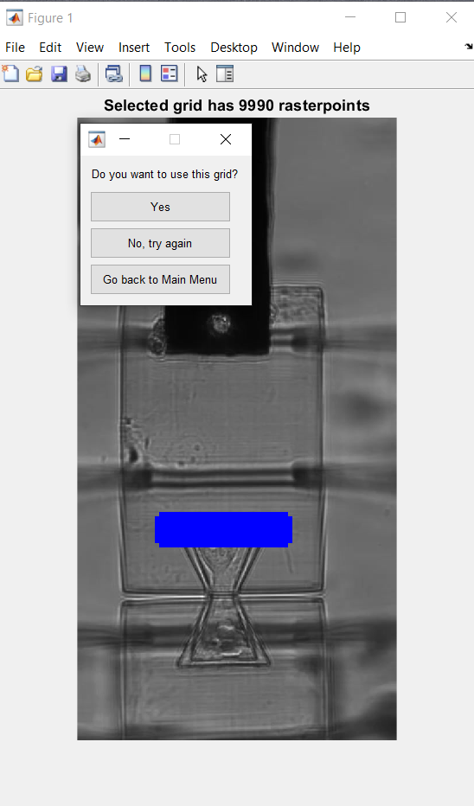

The last dialogue will ask you if you want to use the generated grid and save the grid_x.dat and grid_y.dat to be processed, if you want to try again or if you want to choose another grid type.
You will be asked if you would like to add more points or if you would like to remove markers. If you are happy with the result just hit END.

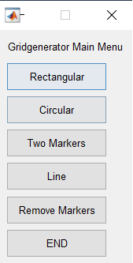

3. Run correlation with “automate_image_HCC.m”.
By running the code, the correlation calculation will automatically run until it finishes.

4. Saving the data
To save the data, run “Displacement_Average.m”. The output is the pixel movement in the series of frames.

